Title: Group IT Functional Specification  <System Name>  <Change Control Reference Number> | Unique Identifier | 240-87435102
 | Revision No. | 9
 | Revision Date | March 2019
 | Effective Date | March 2022
 | Total Pages | 9

Table of Contents
Document Control Information 3
Approval 3
Glossary of Terms 3
Abbreviations 3
Definitions 3
1 Introduction 4
2 Business Requirements 4
3 High-Level Design 4
3.1 System Architecture 4
4 Functional Requirements 4
4.1 List of functions 4
4.2 Use Cases 5
5 Non-Functional Requirements 5
5.1 Transaction Volume 5
5.2 Performance Requirements 5
5.3 Security Requirements 5
5.4 Software Quality Attributes 6
5.5 History Requirements 6
5.6 Archiving Requirements 6
5.7 Frequency 6
5.8 Dependencies 6
5.9 Access Rights (Roles and Profiles) 6
6 Other Requirements 6
7 Functional Design Considerations 6
8 Interface Requirements 7
8.1 Interface Data Structure 7
8.2 User Interfaces 7
8.3 Hardware Interfaces 7
8.4 Software Interfaces 8
8.5 Communications Interfaces 8
8.6 Module Interfaces 8
9 Configuration Changes 8
<Define any other configuration changes that must be applied for this change> 8
10 Testing Requirements 8
10.1 Test Scenarios 8
11 Documents to be updated 8
12 References 9
12.1 Reference Documentation (include reference to test pack) 9
13 Functional Specification Signoff 9

Document Control Information
Effective from | Amendment | Version Number | Modified By

Approval
This document was reviewed and approved in terms of accuracy and completeness by the following stakeholders:

Divisional / Business Representatives | Date | Sections to Review | Signature

Glossary of Terms

Abbreviations
Abbreviation | Description
RFS | Request for service

Definitions
Abbreviation | Description
System | It can be application, or middleware

N.B* All the text highlighted in red must be replaced with the actual details when this document is used.

Introduction
The Functional Specification clearly defines what the functionality of the requested change will be by providing all the information that is necessary to design the requested change. The functional specification should describe the business requirements, the input, processing and output required to meet these User Requirement Specification.

Business Requirements
<Provide a detailed description of the business requirements as stated in section A of the change control form. Define what is in scope and what is not covered in scope and document any activities/processes that this change is dependent on.>

- Purpose - <What the function is intended to accomplish?>
- Input - <What inputs will be accepted, in what format the inputs arrive, sources for the inputs, and other input characteristics?>
- Process - <The steps to be performed, algorithms, formulas, or techniques to be used. However, Software implementation details are not included;> and
- Output - <Desired outcomes such as the output form (e.g. report layout), the destination of the output, output volume and timing, error handling procedures, and units of measure.>

High-Level Design
<This section should set out the high-level design of the system. It should include one or more system models showing the relationship between system components and the systems and its environment.

Refer back to the Investigation and Impact Analysis Document and complete the required architecture sections below. Section 3.1 System Architecture can be used as an example. >

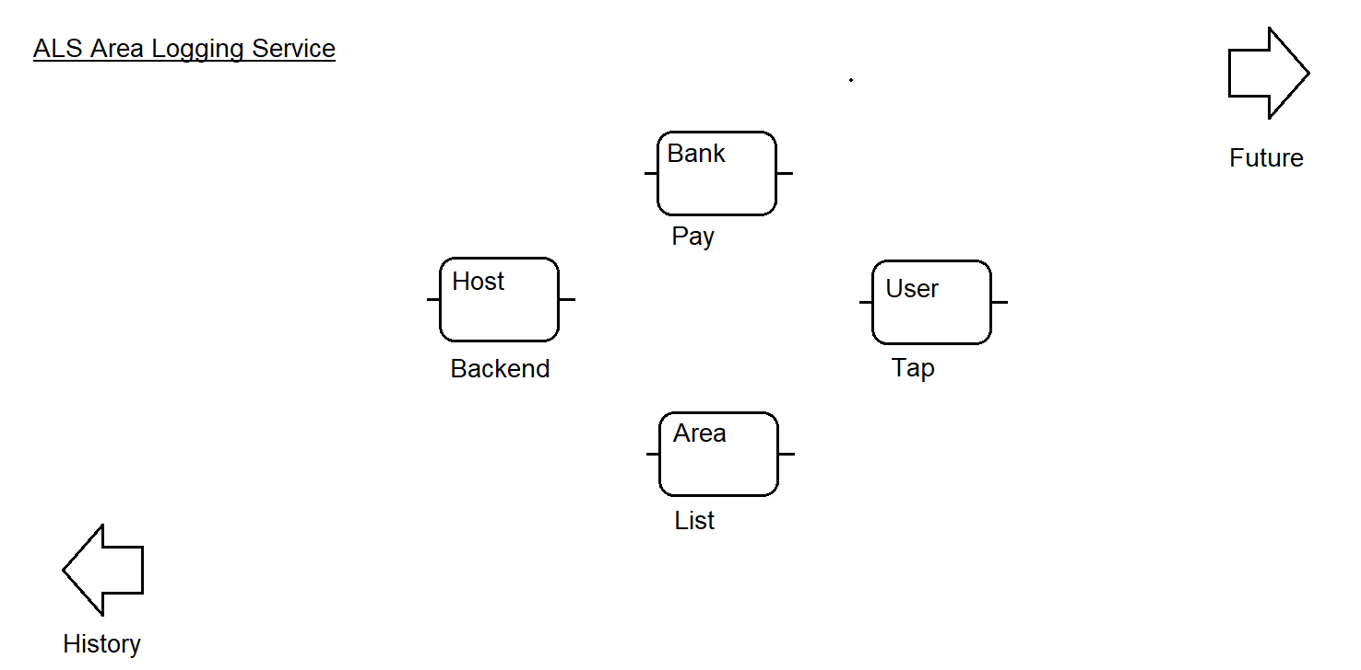

System Architecture
<This section describes a high-level overview of the anticipated system architecture showing the distribution functions across system modules and the relationship between them. System architecture is a representation of the system change to be developed, the process and discipline for effectively implementing the design(s) for such a system change.>

Functional Requirements
<This section contains all the system requirements at a level of detail sufficient to enable designers to design a change to satisfy those requirements, and testers to test that the change satisfies those requirements. These requirements should include at a minimum a description of every input into the system, every output (response) from the system and all functions performed by the system in response to an input or in support of an output. Details on the business value to be delivered is required to define testing scenarios>

List of functions
<This section defines a complete list of the functions of the requested change and can include diagrams or tables or text-based descriptions for each individual function as shown below – whatever is most efficient to explain the functionality. The functions can be grouped into interfaces and associated modules and should detail the following issues:
- Identify modules into which the product will be partitioned;
- Associate interfaces with modules;
- Group the functions into interfaces;
- Describe the data/control flow; and
- Identify the data structures and relationships.

Each function should be described in following terms:

- Description – <the purpose of the function ;>
- Role - <defines the role of the user that will use this function>
- Input arguments – <input format, module that supplies the input, range of valid inputs ;>
- Process – <describes the main steps in pseudo code performed by the function ;>
- Output – <desired output and format, destination for the output i.e. identify the module where the output propagates ;>
- Exceptions – <describe situations when exceptions can occur and the exception handling procedures;>
- Value - <Describe the business value that must be tested;> and
- Comments – <any additional information related to the function of the request change.>

Releases, Sprints and Prioritization

- Where possible break the list of Functional requirements into Releases.
- Assign priority from a business viewpoint for all functions

Use Cases
<Use Cases (Conditions) describe the sequence of events that represent the interaction between the user and the system. These events can be described as pairs of actions performed by the user and the responses of the system. This section should also detail security scenarios and robustness i.e. how the system will react to faulty/invalid inputs or incorrect usage. The specification of use cases is an important requirement since it helps to identify the detailed functionality of the product. User characteristics - describe who will be using the product, i.e. the main characteristics of the user in terms of role and specific knowledge. For example, there might be different use scenarios for different users and these scenarios may also vary according to the affiliation to different groups.

User stories may be defined instead of Use Case diagrams. All user stories should be accompanied by detailed descriptions and prioritisation>

Non-Functional Requirements
If user stories are being used non-functional requirements can be detailed as user stories. All user stories must be accompanied by a detailed description and prioritisation.

Transaction Volume
<Specify data volume requirements>

Performance Requirements

<If there are performance requirements for the requested change under various circumstances, state them here and explain their rationale, to help the developers understand the intent and make suitable design choices. Make such requirements as specific as possible. You may need to state performance requirements for individual functional requirements or features.>

Security Requirements
<Specify any requirements regarding security or privacy issues surrounding the implementation of the requested change or protection of the data used or created by the change. Define any user identity authentication requirements. Refer to any external policies or regulations containing security issues that affect the system. Define any security or privacy certifications that must be satisfied.>

Software Quality Attributes
<Specify any additional quality characteristics for the requested change that will be important to either the customers or the developers. Some to consider are: adaptability, availability, correctness, flexibility, interoperability, maintainability, portability, reliability, reusability, robustness, testability, and usability. Write these to be specific, quantitative, and verifiable when possible. At the least, clarify the relative preferences for various attributes, such as ease of use over ease of learning.>

History Requirements
<Specify history requirements, what historical period data must be available and the level of granularity required (daily/monthly)>

Archiving Requirements
<Specify archiving requirements. How old can data be before it is archived? Does archived data need to be accessible?>

Frequency
<Specify frequency requirements>

Dependencies
<Specify systems that will be impacted by this change and the impact.>

Access Rights (Roles and Profiles)
<Specify roles and profiles requirements. Define the permissions for each role that is impacted. >

Other Requirements
<Define any other requirements not covered elsewhere in the functional specification. This might include database requirements, legal requirements, reuse objectives, and so on. Add any new sections that are pertinent to the requested change.>

Functional Design Considerations
<Functional design considerations describe the operating environment for the product and detail the product’s attributes that affected its functional design. This section should detail the following aspects :>

- Data Structure
- Assumptions that were made during functional design;
- Prerequisites for the correct working of the product;
- Main decisions/reasons regarding functionality;
- Scale of deployment;
- Resource requirements in terms of hardware, data volume, other software or equipment;
- Portability;
- Reliability/Maintainability/Availability;
- Installation;
- Security;
- Configuration and customisation; and
- Error handling.

Interface Requirements

Interface Data Structure
Interface ID: | <Integration team to add interface ID>
Source System: | <Name>
Target System: | <Name>
Integration Mechanism: | <ALE, JCAPS, PI, etc.>
Interface Name: | <example ZPMRMIGO>
Interface Description: | <Describe the purpose of the interface>
Data Format: | <example idoc, flat file>
Direction: | <Inbound or Outbound>

Interface Data Schema

Field Name | Field Description | Data Type | Length | Mandatory | *Business Rule
AUFNR |  | String | 12 | Yes | 1
WARPL |  | String | 12 | Yes | 1
WAPOS |  | String | 16 | No | 2
KTEXT |  | String | 40 | Yes | 3
TPLNR |  | String | 18 | Yes | 3
EQUNR |  | String | 30 | Yes | 4
VAPLZ |  | String | 8 | Yes | 5

<Note: The table above is an example. Please remove the text and complete the table as far as possible.>

Business Rules (*Define business rules if there is any logic required in the mapping)
- <Description of the business rule>
- <Description of the business rule>
- <Description of the business rule>

Sample file
<Embed sample file of the message if available i.e. standard idoc, flat file structure, etc.>

User Interfaces
<Describe the logical characteristics of each interface between the software product and the users. This may include sample screen images, any GUI standards or guides that are to be followed, screen layout constraints, standard buttons and functions (e.g., help) that will appear on every screen, keyboard shortcuts, error message display standards, and so on. Define the software components for which a user interface is needed.>

Hardware Interfaces
<Describe the logical and physical characteristics of each interface between the software product and the hardware components of the system. This may include the supported device types, the nature of the data and control interactions between the software and the hardware, and communication protocols to be used.>

Software Interfaces
<Describe the connections between this software product and other specific software components (name and version), including databases, operating systems, tools, libraries, and integrated commercial components. Identify the data items or messages coming into the system and going out and describe the purpose of each. Describe the services needed and the nature of communications. Identify data that will be shared across software components.>

Communications Interfaces
<Describe the requirements associated with any communications functions required by this product, including e-mail, web browser, network server communications protocols, electronic forms, and so on. Define any pertinent message formatting. Identify any communication standards that will be used, such as FTP or HTTP. Specify any communication security or encryption issues, data transfer rates, and synchronization mechanisms.>

Module Interfaces
<Describe the connections between modules within a software product.>

Configuration Changes

<Define any other configuration changes that must be applied for this change>

Configuration Item | Current | Proposed
<Path> | <C:\java> | <C:\java7>

Testing Requirements
<This section describes the test data required for testing the requested change and the conditions that must be satisfied by the change. Refer to the testing requirements document.>

Test Scenarios
Condition # | Test Steps / procedure | Expected result

Documents to be updated
<Business processes, training documents etc.>

References
<List all documents referenced elsewhere in the functional specification. This information can be provided by reference to an appendix or to another document.>

Reference Documentation (include reference to test pack)
Name | Location

Functional Specification Signoff
This document was reviewed and approved in terms of accuracy and completeness by the following stakeholders:

Role | Name | Signature | Date
Specialist
Functional / Cell Lead
Business Analyst
Requester

